The Bavaria Vision 42

EUR 400,000

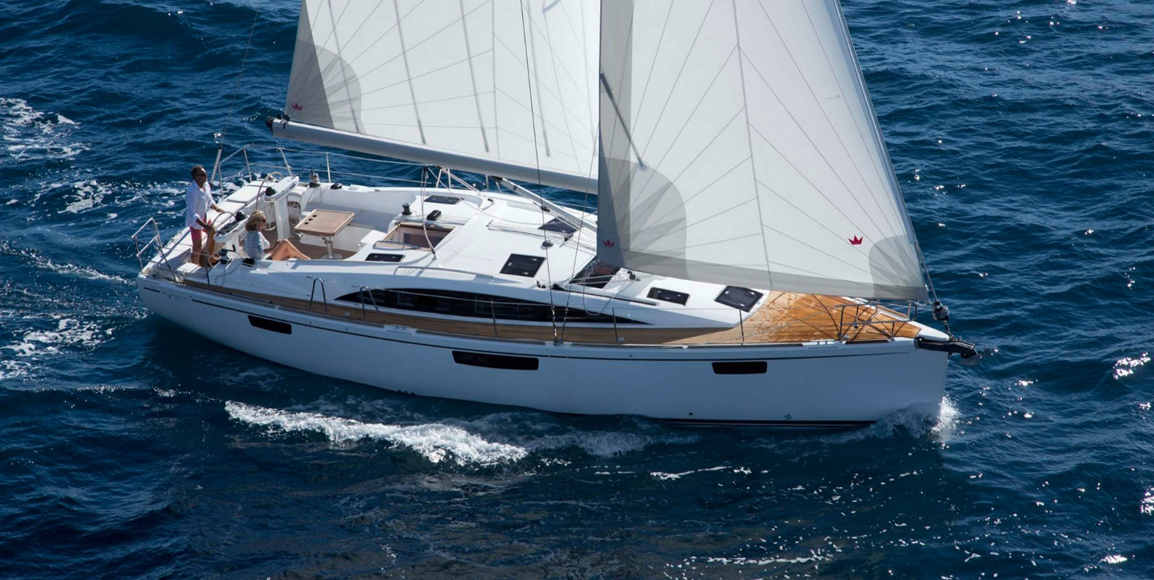

## Asking price: **EUR 400,000**

## Built: **2019, Moscow, Russia**

## Length: **59.2m (290.6ft)**

## Cabins: **2**

## Berths: **4**

# Description:

# First class sailing with 2 cabins.

### With a VISION 42 you will not only experience first class sailing, you will also be a first class sailor! This is made possible by an extraordinary, unique exterior and interior layout. The companionway from the cockpit to the saloon is moved to starboard in the deck assembly, which opens up new possibilities for the cockpit layout – a cockpit table is incorporated, fitted with a handle to transform it into a sleeping surface. There is also is plenty of space for sunbathing behind the two helms – and not only for the helmsman.